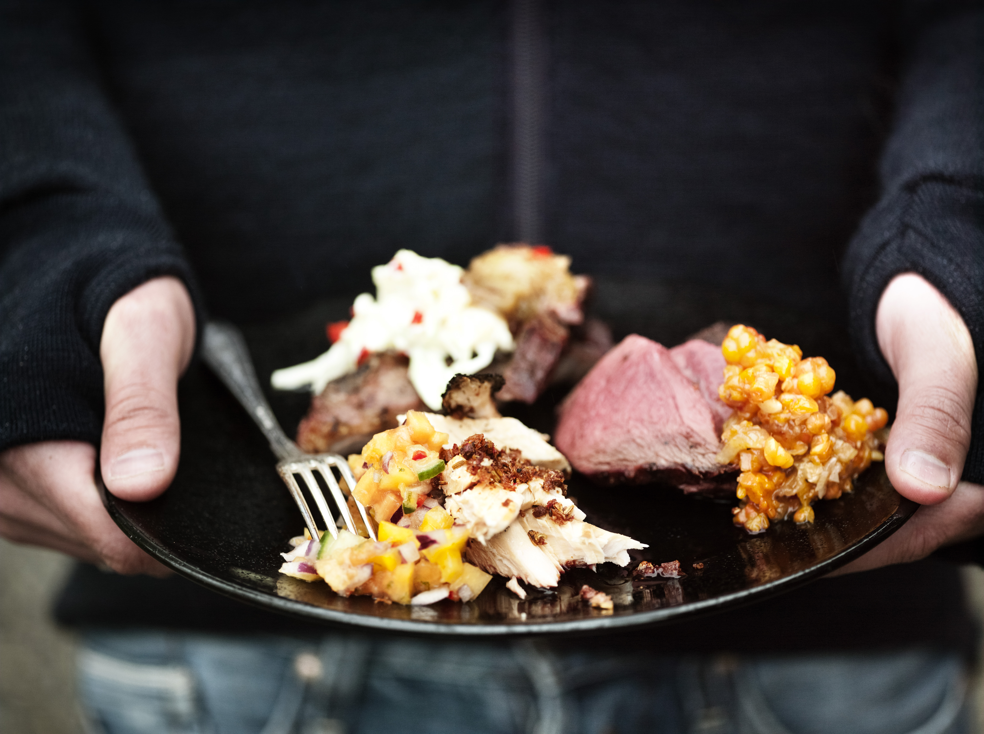
Foto: Tina Stafrén – Gastronomy Jämtland Härjedalen |  | For more information, please contact:  Mrs. Marjut Svanström  marjut.svanstrom@ostersund.se  The Municipality of Östersund
Welcome to Östersund - Creative City of Gastronomy
May 7th - 21st 2025
For your 10 days training period with 6 students and 4 from your staff. 5 days in a cooperative cooking and hostelry services at Odensalaskolan special needs school.
5 days in breakfast service at Hotel Scandic Syd.
We are very pleased to welcome you to visit the City of Östersund and the Region of Jämtland Härjedalen to take part in the following program.
- The aim of the study visit is to:
Bring your students to attend part of their training period
in a different environment with the support of your
teachers.

Program
May 8th -13th 2025
4 days in breakfast service at Hotel Scandic Syd.
Staff representatives at Odensala School's primary special school from eight grade Östersund, will visit the breakfast as guests 9th with 5 students and 3 staff and 13th with 6 students and 4 staff at
kl. 08.20 -9.30.
Weekend Activities (10th and 11th May):
- Moose Garden: Visit to an elk farm.
- Jamtli: Interactive city museum, Sami culture museum, and possible visits to the surroundings.
Wednesday 14th May
9.00-14.00: Arrival at Odensala School. The group will be divided in 3 smaller groups: The student will participate partly at the school restaurants kitchen, tour around the school and partly bake afternoon dessert; chokladrounds (swedish fika) in our smaller consumer literacy classroom.
11.30-12.45
Lunch at Odensala School
Participants:
Dénia delegation of students and staff, Lars-Erik Skybak, chef at Odensalaskolan, Mrs Marjut Svanström, principal and the staff representatives at Odensala School's elementary special school from pre-school to ninth grade Östersund,

Thursday 15th May
12.00-14.00: Group 1. Baking Swedish flatbread at Jamtli.
14.00-16.00: Group 2. Baking Swedish flatbread at Jamtli.
18.00; Odensalaskolan Cabaré
Participants:
Dénia delegation of students and staffstaff representatives at Odensala School's elementary special school from pre-school to ninth grade Östersund,

Friday 16th May
10.45: Lunch at Arctura, water tower top restaurant.
The lunch is hosted by the developmentstrategy office of
Östersund municipality.
After lunch a study visit to Nordansol farm with study and career counselor, Åsa Andersson.
Participants:
Dénia delegation of students and staff, staff representatives at Odensala School's elementary special school from pre-school to ninth grade Östersund. Representatives from the developmentstrategy office
of Östersund municipality. Representatives from Region Jämtland Härjedalen.

Saturday 17th May:
- Classic car show / weekend activities.

Sunday 18th May:
- Pizza at Marjut's house.

Monday 19th May
Dénia delegation of students and staff with preparation for
Spanish dinner between kl. 16-19 which they will cook and serve as outdoor cooking on our schoolyard/schoolrestaurant. Shop for groceries and prepare during the day.
11.30 Lunch at Odensala School
Participants:
Dénia delegation of students and staff, Lars-Erik Skybak, chef at Odensalaskolan, Mrs Marjut Svanström, principal and the staff representatives at Odensala School's elementary special school from pre-school to ninth grade Östersund,

Tuesday 20th May
9.00-14.00: Sportsday at Hofvallen. Try some parasports.
Lunch will be served at Hofvallen.
Participants:
Dénia delegation of students and staff, chef at Odensalaskolan, Mrs Marjut Svanström, principal and the staff representatives and students at Odensala School's elementary special school from pre-school to ninth grade Östersund,

May 21st
Departure
 |  |  | The City of Östersund and the Region of Jämtland Härjedalen have been members of the Unesco Creative Cities Network since 2010. We are designated in the Gastronomy genre, but cities can also be members in other cultural genres.
 |  |  | 

